Given the provided data, what are three conclusions that we can draw about crowdfunding campaigns?

1. Crowdfunding campaigns are becoming more successful over time. The graph below shows the upward trend on the percentage of successful crowdfunding campaigns from 2010 to 2019.
2. All countries have a success rate between 50% and 60%.
3. A majority of crowdfunding projects in the US fail once the goal is higher than $75,000

What are some limitations of this dataset?

One limitation is dataset isn’t in the same currency. When reviewing the full dataset, the goal and pledge columns should be converted to the same currency. Another limitation is the dataset is missing the amount each backer donated. There isn’t visibility into if a small number of backers with large donation led to the successful projects, or if a lot of small donations led to successful projects.

What are some other possible tables and/or graphs that we could create, and what additional value would they provide?

A table could be created that converts all the pledges and goals to the same currency. This would provide better conclusions when analyzing outcomes from multiple countries.

A graph could be created that shows if staff picks increased the chances of a project to have a successful outcome. This would provide insight on if it’s beneficial to pursue to be a staff pick for a future project.

* Use your data to determine whether the mean or the median better summarizes the data.

The median better summarizes the data because there are outliers causing the mean to be skewed.

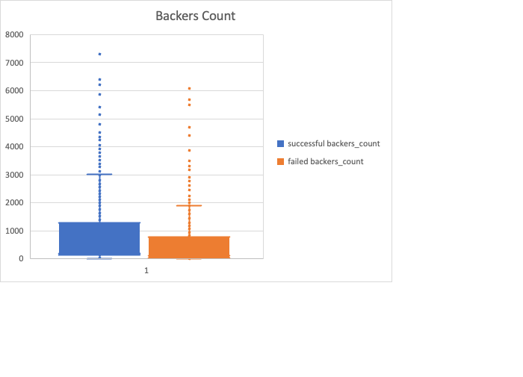

* Use your data to determine if there is more variability with successful or unsuccessful campaigns. Does this make sense? Why or why not?

There is more variability with successful campaigns because the standard deviation for successful campaigns is greater than the standard deviation of unsuccessful campaigns. It makes sense unsuccessful campaigns have less variability because a common attribute for unsuccessful campaigns is the pledge amount is close to 0, which would cause a decrease in variability.